Langcasan,Cilway J.
Beed-3

- Microsoft PowerPoint -Microsoft PowerPoint is a proprietary commercial presentation program developed by Microsoft. Microsoft PowerPoint is used for creating presentations for small to large crowds. The pages in PowerPoint can contain pictures, large texts, graphs, sounds, and other things that can make your presentation more entertaining and easier to understand.

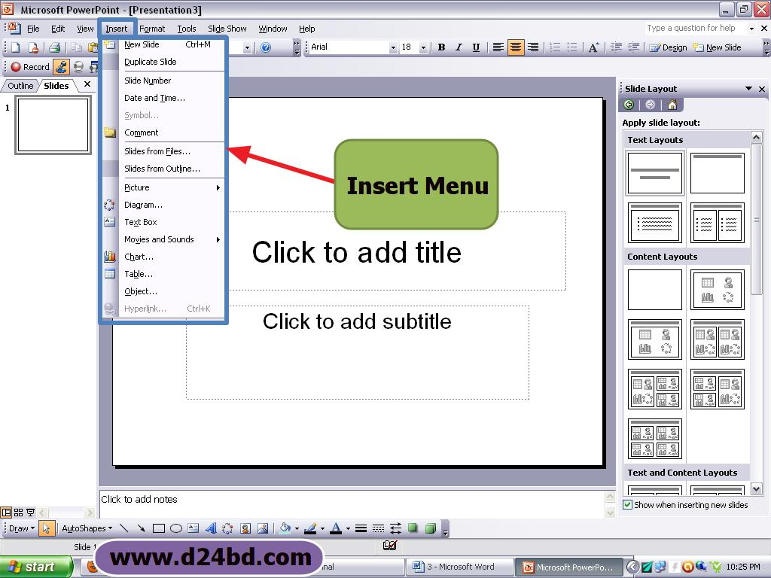

- Internet Explorer -
Internet Explorer (formerly Microsoft Internet Explorer and Windows Internet Explorer, commonly abbreviated IE or MSIE) is a series of graphical web browsers developed by Microsoft and included as part of the Microsoft Windows line of operating systems, starting in 1995. It was first released as part of the add-on package Plus! for Windows 95 that year. Later versions were available as free downloads, or in service packs, and included in the OEM service releases of Windows 95 and later versions of Windows.
Internet Explorer is one of the most widely used web browsers, attaining a peak of about 95% usage share during 2002 and 2003.[4] Its usage share has since declined with the launch of Firefox (2004) and Google Chrome (2008), as well as with the growing popularity of operating systems such as OS X, Linux and Android that do not run Internet Explorer. Estimates for Internet Explorer's overall market share range from 27.4% to 54.13%, as of October 2012 (browser market share is notoriously difficult to calculate). Microsoft spent over US$100 million per year on Internet Explorer in the late 1990s,[5] with over 1000 people working on it by 1999.[6]

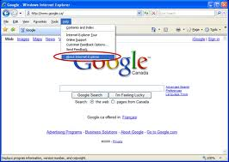

- Windows Media Player-
Windows Media Player (abbreviated WMP) is a media player and media library application developed by Microsoft that is used for playing audio, video and viewing images on personal computers running the Microsoft Windows operating system, as well as on Pocket PC and Windows Mobile-based devices. Editions of Windows Media Player were also released for Mac OS, Mac OS X and Solaris but development of these has since been discontinued.

In addition to being a media player, Windows Media Player includes the ability to rip music from and copy music to compact discs, burn recordable discs in Audio CD format or as data discs with playlists such as an MP3 CD, synchronize content with a digital audio player (MP3 player) or other mobile devices, and enable users to purchase or rent music from a number of online music stores.

Windows Media Player replaced an earlier application called Media Player, adding features beyond simple video or audio playback.

Windows Media Player 11 is available for Windows XP and included in Windows Vista and Windows Server 2008. The default file formats are Windows Media Video (WMV), Windows Media Audio (WMA), and Advanced Systems Format (ASF), and its own XML based playlist format called Windows Playlist (WPL). The player is also able to utilize a digital rights management service in the form of Windows Media DRM.

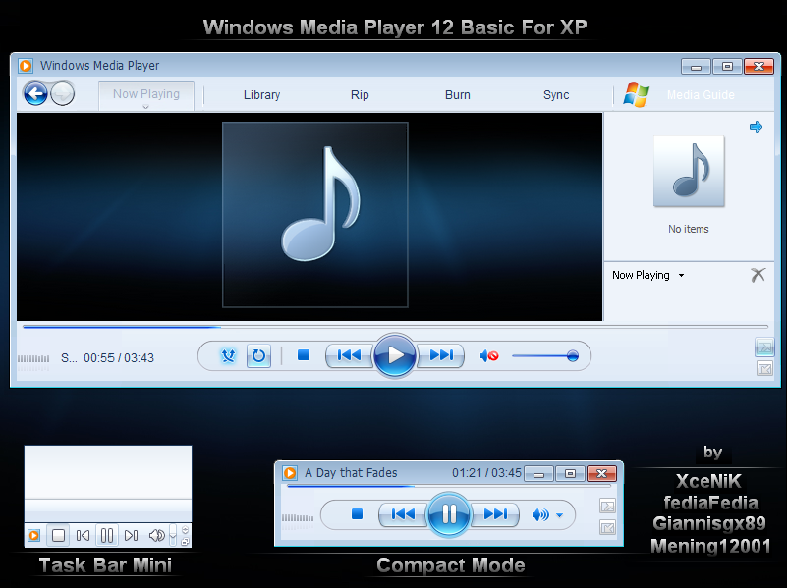

- Gamehouse -GameHouse is a casual game developer, publisher, digital video game distributor, and portal, based in Seattle, Washington, United States.

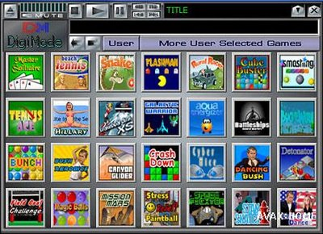

- Cyber link Power -
Cyber Link Power Director is a video editing software application for non-linear video editing, published by Cyber Link Corporation. Power Director allows users to capture, edit and output from within the software and has semi-professional features suitable for the consumer level. Its main competitors are Adobe Premiere Pro and Elements, AVS Video Editor, Corel Video Studio, Pinnacle Studio, and Sony Vegas Movie Studio. Power Director Software can be purchased online or in popular computer retail stores.

